# Algorithms Workshop Week 4

## Run times

Random:

N = 2000 / t = 0.01

N = 4000 / t = 0.09

N = 8000 / t = 0.285

N = 16000 / t = 1.5

Reversed:

N = 2000 / t = 0.038

N = 4000 / t = 0.065

N = 8000 / t = 0.26

N = 16000 / t = 1.48

Sorted

N = 2000 / t = 0.045

N = 4000 / t = 0.049

N = 8000 / t = 0.175

N = 16000 / t = 1.2

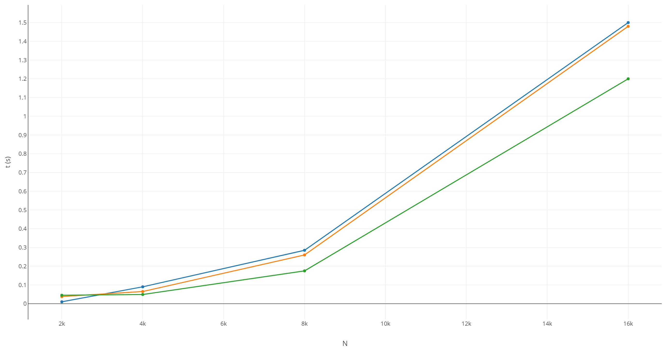

Blue – Random

Orange – Reversed

Green – Sorted